## Lesson 2 – Activity Sheet

## Getting Started

You have been tasked by a major online retailer to use robotics to automate their distribution warehouse

* The robot is parked in its bay (marked P)
* The employees work at the desk in the centre
* The robot needs to be able to automatically go to the correct storage bins, pick the required items and return them to the desk for packaging
* Your robot has sensors to detect the following (Light, Line and Ultrasonic)

The robot accepts the following commands:

FORWARD (Xm) – X being the number of metres

BACKWARDS (Xm) – X being the number of metres

TURN RIGHT or LEFT (X) - X being the number of degrees to turn (90 is a quarter turn)

PICK – automatically picks the item from the bin in front of it

PLACE – places a picked item on the table in front of it

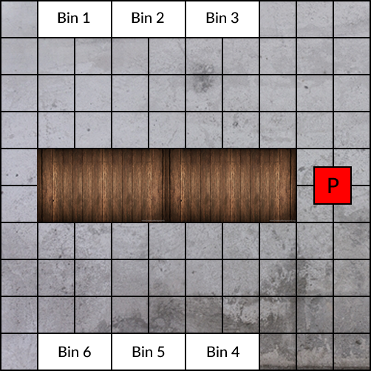

## Success Criteria

* Identify how the sensors would be used to collect the items from the bins and place them on the table
* Produce an algorithm to collect an item from a bin and place it on the table using the commands
* Produce an IPO table for one of the algorithms you have designed

|  |  |  |
| --- | --- | --- |
| **Input** | **Process** | **Output** |
|  |  |  |

## Pro-tip

## Consider all the senses a person would use to do this job. Think about what sensors would a robot need to do the same thing

## Test Time

Think/ pair share your ideas

Swap worksheets with a partner and test their algorithms. For the IPO table think about the following:

* What happens if a worker gets in the way of the robot?
* What happens if the robot drops an item?
* What happens if there is something already on the table?

## Stretch Tasks

* What other sensors could be used?
* What technology could each item in the bins have that would make picking them easier?
* Design an algorithm that deals with the questions in the test time section and any other problems that you can think of that may occur in the warehouse

## Final Thoughts

In this lesson we have explored how robots could be used in a warehouse and what needs to be thought about when programming them and using their sensors to help them complete their tasks.

Consider:

* What are the ethical concerns with using robots in factories over human workers?
* Why may a company want to use robots instead of people?
* What problems may a company encounter if they replaced all their staff with robots, what if all businesses did this?